

Submitted By:
Muhammad Ahmed Subhani
SU92 – BSSEM – S25 – 018
Section: 4-A

Submitted To:
Sir Rasikh Ali

Department of Software Engineering
Superior University, Lahore
LAB 3
Manual Trace of BFS and DFS (Section 3.2)
1. Understand the graph
The following is an adjacency list of the graph:
graph={
"A":["B","C"],
"B":["D","E"],
"C":["F"],
"D":[],
"E":["G"],
"F":[],
"G":[]
}

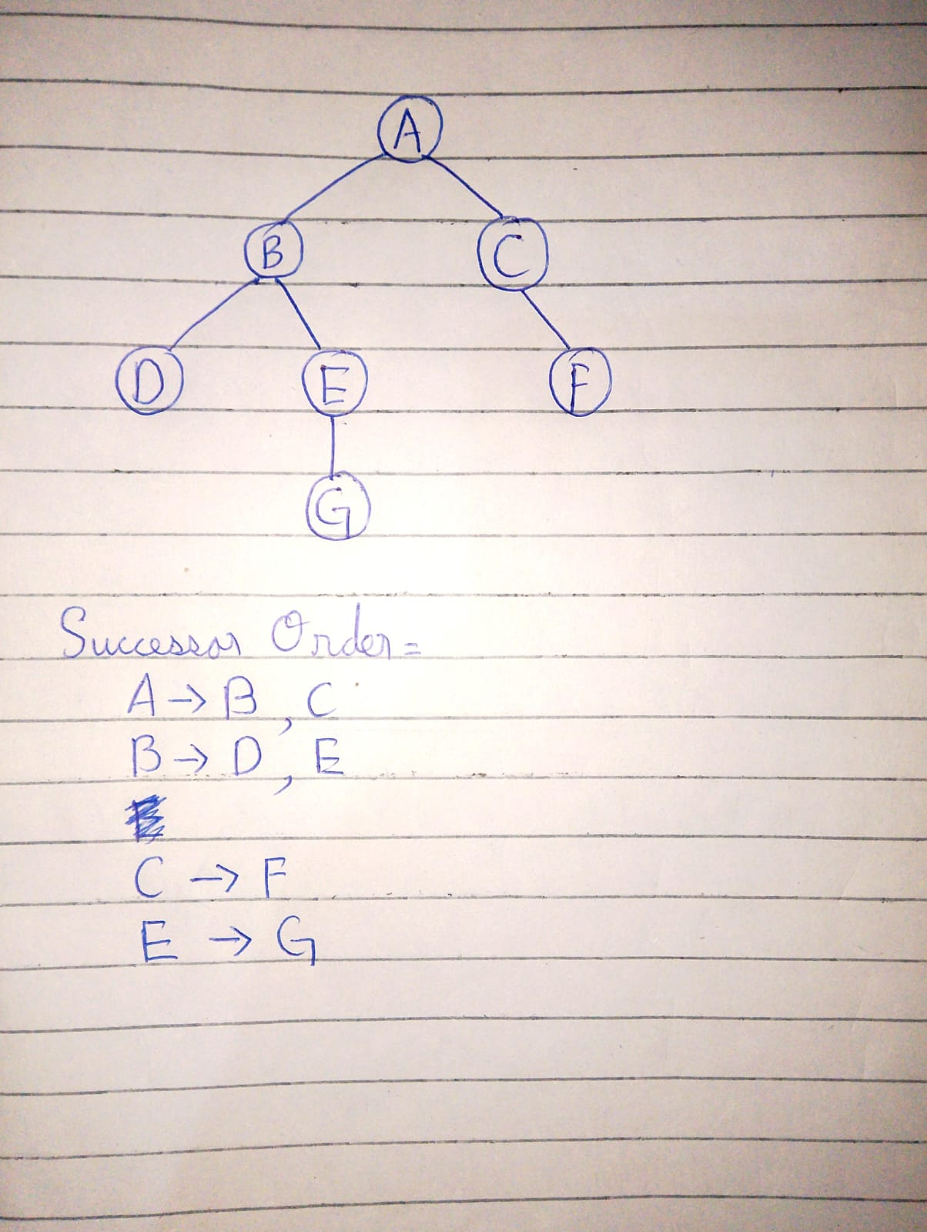

2. Breadth-First Search (BFS)
BFS uses a method know as ( FIFO ) - First In, First Out. The node that is stacked first comes first out too.
That code starts with:

def bfs(start, goal):
q=deque([(start,[start])]); seen={start}
The queues store (node, path) pairs. The seen set is to ensure that nodes are not added to more than once.
Manual queue trace:
Step | Processed node | Queue after processing and adding successors
0 |  | (A, A)
1 | A | (B, A→B), (C, A→C)
2 | B | (C, A→C), (D, A→B→D), (E, A→B→E)
3 | C | (D, A→B→D), (E, A→B→E), (F, A→C→F)
4 | D | (E, A→B→E), (F, A→C→F)
5 | E | (F, A→C→F), (G, A→B→E→G)
6 | F | (G, A→B→E→G)
7 | G | Goal Achieved

At 7 it stops and removes G from stack and shecks:
if node==goal:
return path
If G is the goal, BFS stops and returns immediately.
BFS results
Final path: A → B → E → G
Visit order: A, B, C, D, E, F, G
3. Depth-First Search (DFS)
DFS follows the (LIFO) method Last in - First Out. It processes the most recently added node first.
The supplied code starts with:
stack=[(start,[start])];
seen=set()
For successor loop:
for n in reversed(graph[node]):
stack.append((n,path+[n]))
reversed() because LIFO.
Manual stack trace:
Step | Processed node | Queue after processing and adding successors
0 |  | (A, A)
1 | A | (C, A→C), (B, A→B)
2 | B | (C, A→C), (E, A→B→E), (D, A→B→D)
3 | D | (C, A→C), (E, A→B→E)
4 | E | (C, A→C), (G, A→B→E→G)
5 | G | Goal Acheived

At 5 G is achieved and is poped from the stack
DFS results
Final path: A → B → E → G
Visit order: A, B, D, E, G
These two algorithms visit the same nodes but different paths on this graph, due to their different visit orders. BFS traverses level by level, DFS goes deeper and deeper into a branch before going back to other branches.

